**MM804 GRAPHICS AND ANIMATION Assignment 3 Solution**

**Question 1:**

The medical imaging dataset used for volume rending the model is

<https://nbia.cancerimagingarchive.net/nbia-search/?MinNumberOfStudiesCriteria=1&CollectionCriteria=Lung-PET-CT-Dx>

* The size of the dataset is 32 MB which contains a total of 64 images that are used for volume rendering of the medical images.
* Dimensions of the images are 512*512 and voxel resolution is 5mm.
* Min and Max pixel Intensities are 0 and 512.
* Size of the individual image DICOM file is 515kb

**Question 2:**

Multiple views of the Output Image

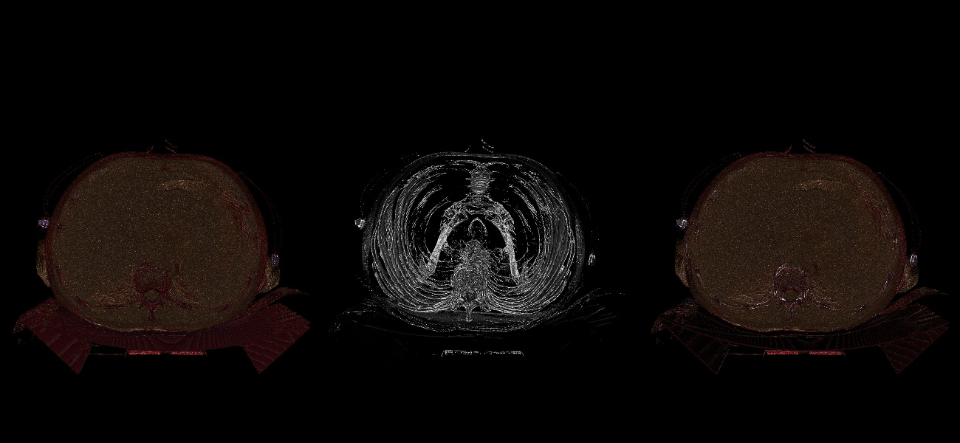

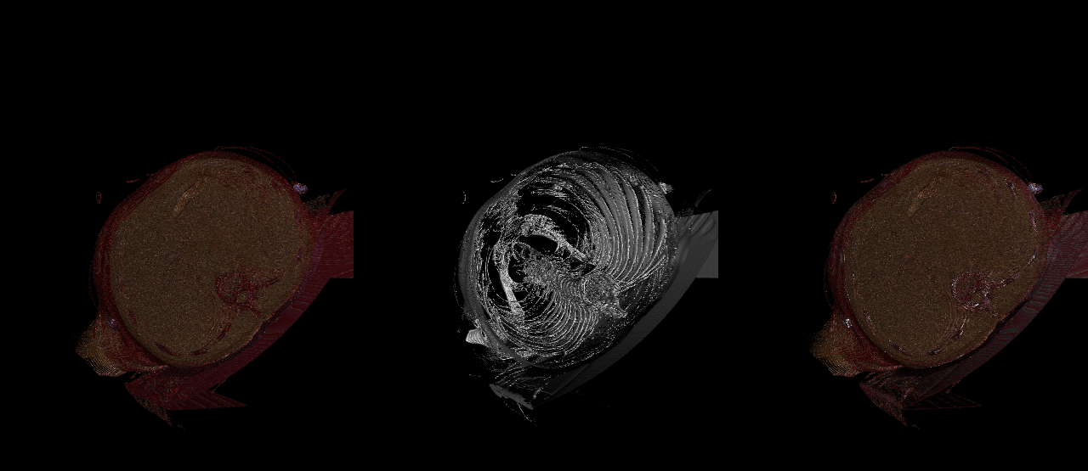

**Question 3:**

Source Code with comments in Human Readable Format

#import vtk library

import vtk

# 1. Reading the Lungs dataset using vtkDICOMImageReader class.

inputDataReader = vtk.vtkDICOMImageReader()

inputDataReader.SetDirectoryName("Lungs")

inputDataReader.Update()

# 2. Creating a random a colour transfer function using the following values.

colorTransferFunction = vtk.vtkColorTransferFunction()

colorTransferFunction.AddRGBPoint(-3024, 0.0, 0.0, 0.0)

colorTransferFunction.AddRGBPoint(-77, 0.5, 0.2, 0.1)

colorTransferFunction.AddRGBPoint(94, 0.9, 0.6, 0.3)

colorTransferFunction.AddRGBPoint(179, 1.0, 0.9, 0.9)

colorTransferFunction.AddRGBPoint(260, 0.6, 0.0, 0.0)

colorTransferFunction.AddRGBPoint(3071, 0.8, 0.7, 1.0)

# 3. Create a opacity transfer function using the following values.

opacityTransferFunction = vtk.vtkPiecewiseFunction()

opacityTransferFunction.AddPoint(-3024, 0.0)

opacityTransferFunction.AddPoint(-77, 0.0)

opacityTransferFunction.AddPoint(180, 0.2)

opacityTransferFunction.AddPoint(260, 0.4)

opacityTransferFunction.AddPoint(3071, 0.8)

# 4. Create viewports and render the dataset in multiple view ports

# Using Volume rendering for Viewport 1

ctVolumeMapper = vtk.vtkSmartVolumeMapper()

ctVolumeMapper.SetInputConnection(inputDataReader.GetOutputPort())

# Add the opacity and colour transfer functions

ctVolumeProperty = vtk.vtkVolumeProperty()

ctVolumeProperty.SetScalarOpacity(opacityTransferFunction)

ctVolumeProperty.SetColor(colorTransferFunction)

ctVolumeProperty.ShadeOn()

# Define a volume actor

ctVolume = vtk.vtkVolume()

volumeRenderer = vtk.vtkRenderer()

# Set volume actor properties

ctVolume.SetMapper(ctVolumeMapper)

ctVolume.SetProperty(ctVolumeProperty)

volumeRenderer.AddVolume(ctVolume)

# 5. In viewport 2, display the iso-surface extracted at suitable intensity value of 300 using marching cubes algorithm

isoSurface = vtk.vtkMarchingCubes()

isoSurface.SetInputConnection(inputDataReader.GetOutputPort())

isoSurface.ComputeGradientsOn()

isoSurface.ComputeScalarsOff()

# print (isoSurface.GetValue(0))

isoSurface.SetValue(0, 300)

# Polydata mapper for the iso-surface

isoMapper = vtk.vtkPolyDataMapper()

isoMapper.SetInputConnection(isoSurface.GetOutputPort())

isoMapper.ScalarVisibilityOff()

# Actor for the iso surface

isoActor = vtk.vtkActor()

isoActor.SetMapper(isoMapper)

isoActor.GetProperty().SetColor(1.,1.,1.)

## renderer and render window

isoSurfaceRenderer = vtk.vtkRenderer()

## add the actors to the renderer

isoSurfaceRenderer.AddActor(isoActor)

# 6. Create a Volume Rendering + Iso Surface for View Port3

combineRenderer = vtk.vtkRenderer()

# Reuse actor and volume

combineRenderer.AddActor(isoActor)

combineRenderer.AddVolume(ctVolume)

#Rendering window

# Create a render window with three viewports

minX=[0,0.33,0.66]

maxX=[0.33,0.66,1]

minY=[0,0,0]

maxY=[1,1,1]

mainWindow = vtk.vtkRenderWindow()

windInteract = vtk.vtkRenderWindowInteractor()

mainWindow.SetSize(1300,600)

windInteract.SetRenderWindow(mainWindow)

# SetActiveCameras to the ActiveCamera of the first renderer

# This allows the visualization to be viewed from same angel in all three viewports

isoSurfaceRenderer.SetActiveCamera(volumeRenderer.GetActiveCamera());

combineRenderer.SetActiveCamera(isoSurfaceRenderer.GetActiveCamera());

volumeRenderer.ResetCamera()

# 7. Add the renderers to main window

mainWindow.AddRenderer(volumeRenderer)

mainWindow.AddRenderer(isoSurfaceRenderer)

mainWindow.AddRenderer(combineRenderer)

# Set the location for the 3 view ports

volumeRenderer.SetViewport(minX[0],minY[0],maxX[0],maxY[0])

isoSurfaceRenderer.SetViewport(minX[1],minY[1],maxX[1],maxY[1])

combineRenderer.SetViewport(minX[2],minY[2],maxX[2],maxY[2])

mainWindow.Render()

windowToImage = vtk.vtkWindowToImageFilter()

windowToImage.SetInput(mainWindow)

windowToImage.Update()

imageWriter = vtk.vtkJPEGWriter()

imageWriter.SetInputConnection(windowToImage.GetOutputPort())

imageWriter.SetFileName('output.jpg')

imageWriter.Write()

windInteract.Initialize()

windInteract.Start()

**Question 4:**

Readme File attached in the submission folder and can be found in the GitHub link

**Development Environment**

- Python - 3.10.0

- VTK - 9.1.0

- OS - Windows 11

**How to run:**

Open the file volumeRendering.py either in Google Colab or Jupyter-Notebook and run the file using the below command for the desired output.